I-ROCK Test Data Summary Report

Category: Phyiscal Property Testing

Test Preformed: Youngs Modulus

Test Results: 120,000 psi – 141,141 psi

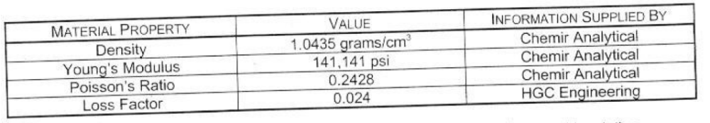

Test Preformed By: Chemir Analyhcal Services. Sandia National Laboratories

